CHRIST (Deemed to be University), Bangalore
School of Sciences
Department of Computer Science
Labyrinth Student Engagement Workshops Report for INTERFACE 2026
Event Report:-
Synopsis:
As part of the Peer Education Series, Labyrinth conducted an array of events for non-participating students in Interface 2026. Designed to ensure that every attendee had a hands-on role in the symposium, the program brought together visual design and practical technical training. The schedule centered on Three core activities:- Quiz, Debates and Workshops (an infographic-making competition to test visual communication skills, an introductory Tinkercad workshop covering basic 3D modeling, and a prompt engineering workshop focused on working effectively with AI tools).
To keep attendees fully engaged, a live quiz with an active leaderboard was organized alongside debate on hot topics, the workshop sessions were structured around a direct learn-and-apply model. Students attended the guided workshops and then immediately put their new knowledge to the test by taking part in a short competition/project for each topic covered. By pairing real-time instruction with quick competitive challenges, Labyrinth allowed non-participating students to gain valuable practical skills while taking an active part in Interface 2026.
Activity 1 : AI Quiz

Type of Activity | AI Quiz
Title of the Activity | Cognify
Date/s | 26th June 2026
Time | 9:45-10:15
Venue | Main Auditorium, Audi Block
Mode | Offline
Collaboration | AI Vertical

Speakers/Resource Persons Details:
Name | Title/Position
Advaith | Student Event Co-ordinator (3 BCA B)

Participants Profile:
Type of Participants | Computer Science Department
No. of Participants | 350+

Highlights of the Event
- Conducted a single-round, timed quiz consisting of 15 questions structured across easy, medium, and hard difficulty levels.
- Implemented a scoring system combining base correct-answer points with time-sensitive speed bonuses to evaluate response quickness alongside accuracy.
- Tested concepts across AI and machine learning domains, including computer vision, supervised learning, NLP, model overfitting, evaluation metrics, and algorithmic bia

Key Takeaways
- Participants applied core knowledge of foundational AI concepts, model mechanics, and practical system limitations.
- The time-capped format reinforced real-time recall, precision, and quick decision-making under pressure.

Activity 2 : AI Debate

Type of Activity | Debate
Title of the Activity | AI Debate
Date/s | 26th June 2026
Time | 10:30 - 11:20
Venue | Main Auditorium, Audi Block
Mode | Offline
Collaboration | Debate Vertical

Speakers/Resource Persons Details:
Name | Title/Position
Kishore | Debate Co-ordinator (1BALLB)

Participants Profile:
Type of Participants | Computer Science Department
No. of Participants | 6 Participants + 350 (Audience)

Highlights of the Event
- Held structured head-to-head debates using a strict eight-minute format per pair, dividing time equally between main arguments, rebuttals, and cross-questioning.
- Debated ethical, legal, and socio-economic propositions, including AI companion impact on human relationships, legal liability for AI decisions, and worker compensation for AI job displacement.
- Evaluated participants using a 30-point rubric covering argument quality, factual evidence, rebuttal capability, delivery, and cross-questioning performance.

Key Takeaways
- Students analyzed the broader societal, legal, and economic implications of AI technology beyond technical implementation.
- Participants built practical skills in structured argumentation, quick counter-argument formulation, and clear verbal delivery.
Activity 2 : Tinkercad Workshop

Type of Activity | Tinkercad Project Building Workshop
Title of the Activity | Tinkercad Workshop
Date/s | 26th June 2026
Time | 11:30 - 2:30
Venue | Campus view, Central Block
Mode | Offline
Collaboration | Robotics and Internet of Things vertical

Speakers/Resource Persons Details:
Name | Title/Position
Suhan Krishna | Student Speaker

Participants Profile:
Type of Participants | Computer Science Department
No. of Participants | 42
Highlights of the Event
- Introduced students to the Tinkercad workspace, interface navigation, and virtual circuit simulation tools.
- Conducted a guided hands-on tutorial led by the resource person on building and programming a functional two-way traffic light system.
- Challenged participants to apply their learning by designing and logic-building a complete four-way highway traffic light system.
- Fostered practical problem-solving, hardware visual planning, and basic control logic design in a simulated environment
Key Takeaways
- Students acquired foundational skills in electronic prototyping, breadboard layout, and signal timing logic.
- Participants strengthened their ability to scale basic circuit concepts into more complex multi-lane systems.
- The session highlighted the value of digital simulation tools for testing hardware ideas before physical implementation.
Activity 3 : Prompt-Engineering Workshop

Type of Activity | Prompt Engineering Workshop & Promptverse
Title of the Activity | Prompt Engineering
Date/s | 26th June 2026
Time | 11:30 - 2:30
Venue | Room-911 , Central Block
Mode | Offline
Collaboration | AI Vertical

Speakers/Resource Persons Details:
Name | Title/Position
Nithin Satya | Student Speaker (7 BCA)

Participants Profile:
Type of Participants | Computer Science Department
No. of Participants | 139

Highlights of the Event
- Introduced the fundamental mechanics of Large Language Models (LLMs) and Transformer architectures.
- Demonstrated side-by-side examples of effective versus ineffective prompts to illustrate key principles of prompt structure.
- Showcased live prompt execution to analyze output variation and accuracy in real time.
- Evaluated participant entries based on factual depth, visual aesthetics, clarity, and spatial information density.
- Fostered critical thinking, design literacy, and precise technical communication through an interactive prompt engineering contest.

Key Takeaways
- Students gained a practical understanding of how structured prompting improves output quality in modern AI workflows.
- Participants strengthened their hands-on skills in writing, refining, and troubleshooting prompts for specific tasks.
- The event emphasized the importance of context, clarity, and iterative testing when collaborating with generative AI tools.
Summary
The Department of Computer Science, CHRIST (Deemed to be University), organized the Student Engagement Workshops for Interface 2026, conducted by the Labyrinth Computer Science Club, to provide a learning environment for non-participating students. The event covered visual design, circuit simulation, prompt engineering, AI domain knowledge, and technical debate. In the Infographic Workshop, participants used Canva to create visual presentations of computer science concepts. The Tinkercad Workshop introduced basic circuit design, where students built a two-way traffic light setup and expanded it into a four-way system. In the Prompt Engineering Workshop, students learned about Large Language Models and Transformer architectures, practicing effective prompt structure through live testing. Additionally, the Cognify AI Quiz evaluated core machine learning principles through a timed format, while the AI Debate challenged students to argue the legal, social, and economic impacts of AI. By merging practical execution with competitive problem-solving, Labyrinth successfully equipped non-mainstage participants with skills in visual communication, circuit logic, AI workflows, and structured argumentation.
Report prepared by:

Name | Akshat Saini
Designation/Title | Core Member- Labyrinth 2026-27
Signature | aksht.t
Email | akshat.saini@bcah.christuniversity.in

GEO-TAG PICTURES:

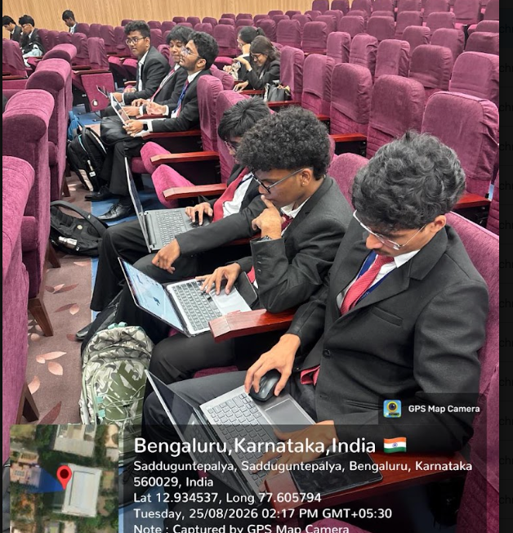 | 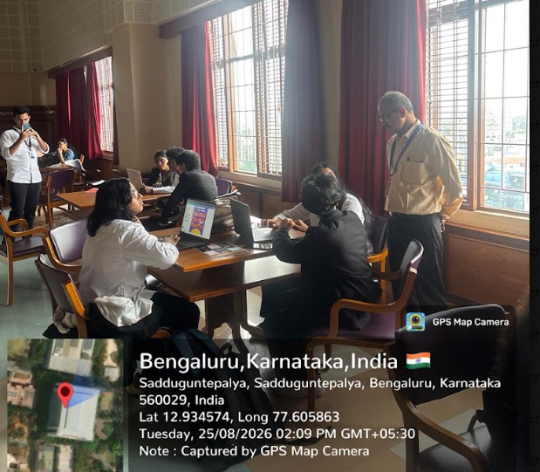
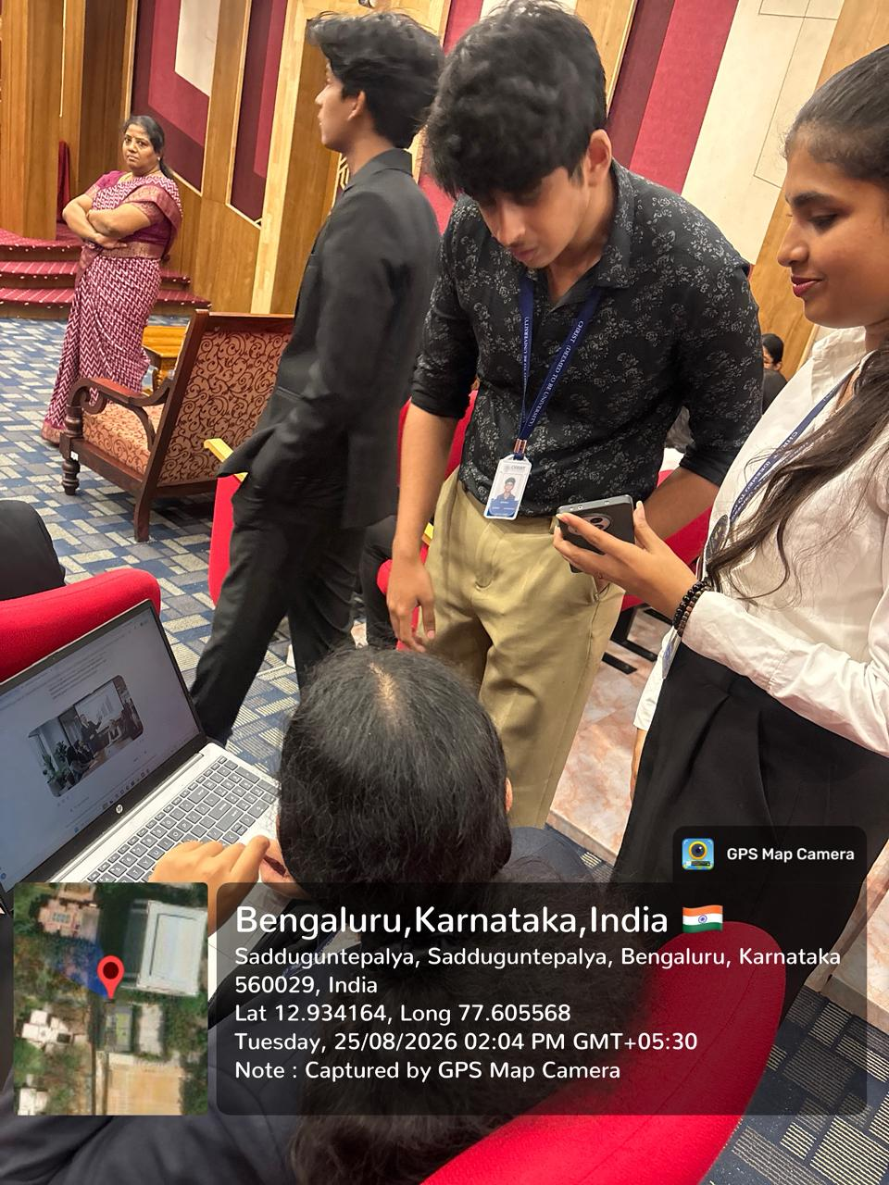 | 